Summary
This report documents a practical security analysis exercise where SQL Injection (SQLi) and Cross-Site Scripting (XSS) attacks were performed on the Damn Vulnerable Web Application (DVWA). The Apache access logs generated during the attacks were ingested into Splunk for detection and analysis.
The exercise successfully demonstrated:

- How SQLi payloads can bypass authentication and extract database records
- How XSS payloads execute in a victim's browser
- How these attacks leave identifiable traces in web server logs
- How Splunk can be used to detect and investigate such threats in real-time

Introduction
Web application attacks remain one of the most common vectors for data breaches. SQL Injection and Cross-Site Scripting are consistently listed in the OWASP Top 10 vulnerabilities.

Understanding how these attacks appear in logs is critical for:

- SOC Analysts – to detect and respond to threats
- DFIR Teams – to investigate security incidents
- Blue Teams – to build detection rules

This hands-on exercise bridges the gap between theoretical knowledge and practical log analysis using Splunk SIEM.

Lab Environment Setup
Component Details
Web Application DVWA (Damn Vulnerable Web Application)
Web Server Apache via XAMPP
Database MySQL
Operating System Windows 10/11
SIEM Tool Splunk Enterprise / Splunk Free
Browser Chrome / Firefox
Log Source C:\xampp\apache\logs\access.log
DVWA Security Level: Low (for demonstration purposes)

Attack Simulation – SQL Injection
1 Payload Used
sql
1' OR '1'='1' --
2 URL Encoded Version
text
1%27+OR+%271%27%3D%271%27+--
3 Injection Point
User ID input field on DVWA SQL Injection page.

4 Original Query (Behind the Scenes)
sql
SELECT first_name, last_name FROM users WHERE user_id = '$id';
5 Injected Query (After Payload)
sql
SELECT first_name, last_name FROM users WHERE user_id = '1' OR '1'='1' --';

6 Result Returned

ID | First Name | Surname
1 | admin | admin
2 | Gordon | Brown
3 | Hack | Me
4 | Pablo | Picasso
5 | Bob | Smith

7 Login Bypass Example
Login Query:

sql
SELECT * FROM users WHERE username = '<input_username>' AND password = '<input_password>'
After Injection:

sql
SELECT * FROM users WHERE username = 'admin' AND password = '' OR '1'='1'
✅ The condition '1'='1' is always true, bypassing authentication.

5. Attack Simulation – Cross-Site Scripting (XSS)

1 Payload Used (Reflected XSS)
html
<script>alert('XSS Attack')</script>
2 URL Encoded Version
text
%3Cscript%3Ealert(%27XSS%20Attack%27)%3C/script%3E
3 Injection Point
Name input field on DVWA XSS (Reflected) page.

4 Behavior
The payload is reflected back in the response

Browser executes the script

Alert box appears with the message

5 Log Evidence
The payload appears clearly in the GET request of the access log:

text
GET /DVWA/vulnerabilities/xss_r/?name=%3Cscript%3Ealert(%27XSS%20Attack%27)%3C/script%3E
6. Log Collection & Ingestion into Splunk
1 Log Source Location
text
C:\xampp\apache\logs\access.log
2 Sample Log Entry (Before Attack)
text
::1 - [16/Apr/2026:21:53:09 +0530] "GET /DVWA/dvwa/js/add_event_listeners.js HTTP/1.1" 304 - "http://localhost/DVWA/vulnerabilities/xss_r/" "Mozilla/5.0"
3 Sample Log Entry (During SQLi Attack)
text
::1 - [16/Apr/2026:21:55:44 +0530] "GET /DVWA/vulnerabilities/sqli/?id=12&Submit=Submit HTTP/1.1" 200 611 "http://localhost/DVWA/vulnerabilities/sqli/?id=1+OR+1%3D1+-&Submit=Submit" "Mozilla/5.0"

4 Splunk Ingestion Steps
- Open Splunk Web Interface
- Go to Settings → Add Data → Monitor
- Select Files & Directories
- Browse to C:\xampp\apache\logs\access.log
- Set Source Type = apache_access_logs
- Set Index = web_logs
- Review and Submit

5 Verification Query
spl
index="web_logs" sourcetype="apache_access_logs"
| stats count by host
7. Splunk Search & Analysis
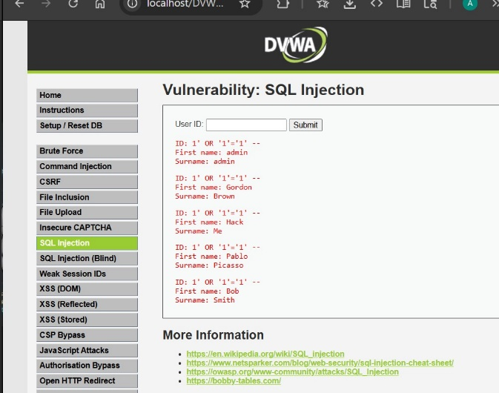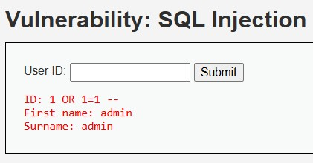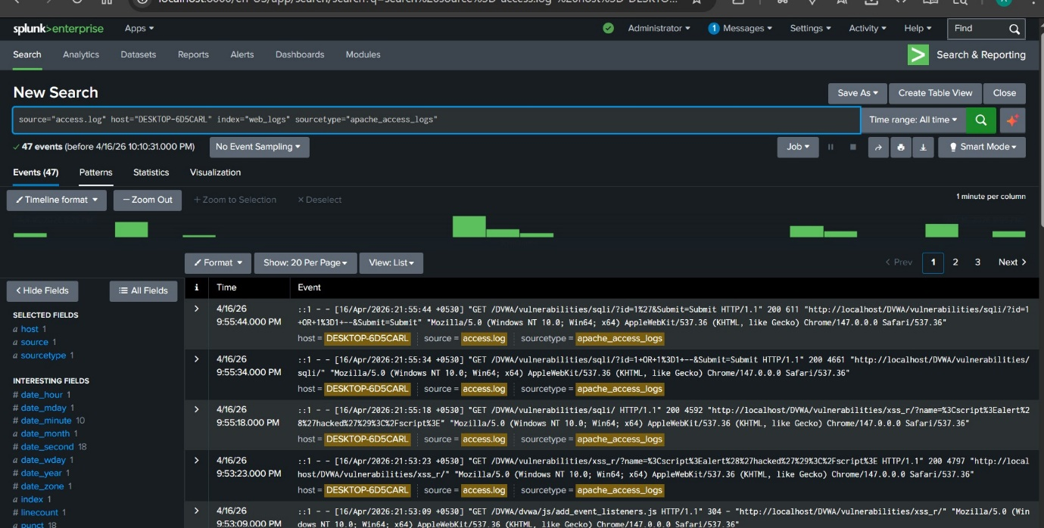
Observed Events:

Time | Event
9:55:44 PM | GET /DVWA/vulnerabilities/sqli/?id=12&Submit=Submit
9:55:34 PM | GET /DVWA/vulnerabilities/sqli/?id=1+OR+1%3D1+-&Submit=Submit
9:55:18 PM | GET /DVWA/vulnerabilities/sqli/?id=1+OR+1%3D1+-&Submit=Submit
8. Detection Use Cases
Use Case | Splunk Query | Alert Trigger
SQLi Attempt | index=web_logs "OR" "1=1" | > 3 attempts in 1 min
XSS Attempt | index=web_logs "<script>" | Any occurrence
12. References
- OWASP SQL Injection
- OWASP Cross-Site Scripting (XSS)
- SQL Injection Cheat Sheet
- Splunk Search Reference
- Bobby Tables – SQL Injection Explanation
- DVWA Project

